### River Flow Calculation Solution

**Prepared By –**

Prateek Garg

R Systems

**Problem:**

To calculate the volume of water that moves through a specific point in a stream. To determine the river flow, the cross-sectional area of the stream is multiplied by the velocity of the river. Consider improved accuracy of the flow, by sectioning the cross-section in order to take multiple measurements of the depth and velocity (as shown in the diagrams below).

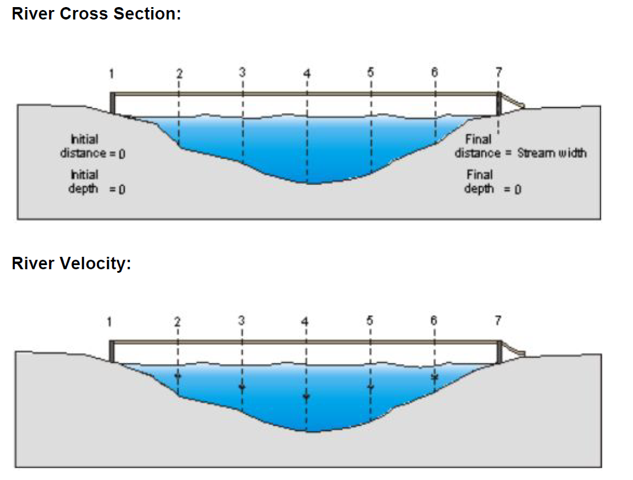

**Assumptions**

1. Multiple measurements of depths are taken and saved in depthMeasurements.dat files.
2. Multiple measurements of velocities are taken and saved in depthMeasurements.dat. Velocities can be pre-calculated by taking fixed stream length ‘L’ and take multiple readings of time taken ‘T’ by float object to travel length ‘L’. Then find out multiple velocity readings by dividing ‘L’ by different values of ‘T’.
3. Both the dat files are saved at same location from where binary/exe file is executed.
4. All depth measurements are in ft.
5. All velocities are measured in ft / second.
6. The stream bottom surface could be rocky or muddy. This could impact the total volume of flow. In order to have better estimate of volume, assumed coefficient for rocky bottom stream as 0.8 and muddy water stream as 0.9.

**References**

Reference the below link for stream flow volume calculations:

<https://archive.epa.gov/water/archive/web/html/vms51.html#:~:text=Calculate%20the%20cross%2Dsectional%20area,2%20is%206.25%20square%20feet>.

**Environment**

Compiled and tested in the below environment:

Compiler – g++ (GCC) 8.2.0

Operating System – centOS Linux 7.8.2003

**Proposed Solution**

**Calculate Volume of water**

To calculate the volume of water that flows through specific point in stream, following formula is used.

Flow = C*A*V

Where:

C = A coefficient or correction factor (0.8 for rocky-bottom streams or 0.9 for muddy-bottom streams). This allows you to correct for the fact that water at the surface travels faster than near the stream bottom due to resistance from gravel, cobble, etc. Multiplying the surface velocity by a correction coefficient decreases the value and gives a better measure of the stream's overall velocity.

A = Average cross-sectional area of the stream (stream width multiplied by average water depth).

V = Velocity, in ft/second (considered avg velocity by taking multiple measurements of time for float to travel fixed length L. Then divide L by average time T).

**Calculate Cross Sectional Area**

Cross-sectional area (A in the formula) is the product of stream width multiplied by average water depth. Determine the average depth along the transect by marking off equal intervals along the string with the twist ties.

E.g the intervals could be one-fifth, two-fifth, three-fifth and four-fifths of the distance across the stream. Measure the water's depth at each interval point. To calculate average depth, divide the total of the four depth measurements by 5. (Divide by 5 instead of 4 because we need to account for the 0 depths that occur at the shores.)

The width of each transect by measuring the distance from shoreline to shoreline. Simply add together all the interval widths to determine its width.

For this assignment, we are reading depth measurements from DepthMeasurements.dat file and stream width is passed as command line parameter.

Calculate the cross-sectional area of each transect by multiplying width times average depth.

**Calculate Average Velocity**

Multiple readings of velocity can be pre-calculated by taking fixed stream length ‘L’ and take multiple readings of time taken ‘T’ by float object to travel length ‘L’. Then find out multiple velocity readings by dividing ‘L’ by different values of ‘T’.

For this assignment, we are reading velocity measurements from VelocityMeasurements.dat file.

**Command used for compilation**

g++ -std=c++17 Main.cpp StreamFlow.cpp -o StreamFlow.exe

**Usage-**

./StreamFlow.exe <stream width> [stream type]

stream width - width of stream

stream type - optional, possible values 1 or 2

1 is for rocky bottom stream

2 is for muddy bottom stream

**Sample Input from dat files**

cat DepthMeasurements.dat (command to list file contents)

1.5

6.0

7.0

0.5

cat VelocityMeasurements.dat (command to list file contents)

3.0

4.0

5.0

6.0

7.0

**Sample Output (with sample input from dat files)-**

./StreamFlow.exe 100 1

The values read from DepthMeasurements.dat - 1.5 6 7 0.5

The values read from VelocityMeasurements.dat - 3 4 5 6 7

avg cross sectional area is 300 sq ft

avg velocity is 5 ft per second

Stream flow volume at given point is 1200 cubic feet per second